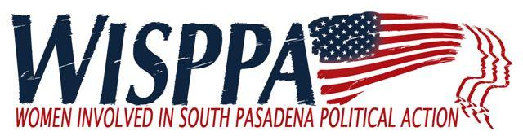

AGENDA
February 2, 2019

9:00 a.m. Conversation & Refreshments
9:30 a.m. Business Meeting
11:00 Adjournment

MEETING LOCATION: South Pasadena Senior Center 1102 Oxley Street

- Call to Order (9:30)

- Introduction of New or Prospective Members and Guests (9:30)

- Approval of Minutes from Jan 12, 2019

- Panel: Community Connections: The Natural Side of South Pasadena (9:40) Bianca Richards
Panelists: Dr. Peter Kalmus, Barbara Eisenstein, William J. Kelly, City Council Member, Dr. Richard Schneider.

- Old Business
  - None

- New Business (10:55)
  - The Pasadena Celebrates 2020 will celebrate the centennial anniversary of American women winning the right to vote. Do we want WISPPA to be participate? Set up a committee to pursue? Planning is proceeding, under the umbrella of a 501 (c) 3 entity, the National Women’s History Alliance, by a group of local organizations and individuals, largely in Pasadena, in collaboration with folks in Rochester, New York.

- Reports
  - No Reports this month –

- Membership Comments, Announcements and Adjournment (11:00)

Next Meeting: Saturday, March 2 Business meeting including updates on Commissions, City Council reports, etc. Main topic – Possible WISPPA name change.

