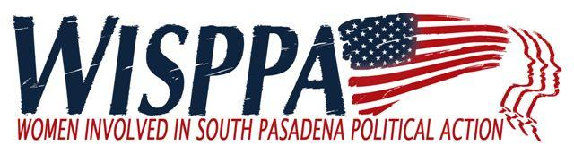

AGENDA
October 7, 2017

8:30 a.m. Coffee and Social Time (Refreshments courtesy of Barbara Sinclair)
9:00 - 9:30 a.m. Business Meeting/Community Update
9:30– 10:30 a.m. Speaker
10:30 a.m. Social Time

MEETING LOCATION: Calvary Presbyterian Church

- Call to Order (9:00)

- Introduction of New or Prospective Members and Guests (9:00)

- New Business (9:05)
  - Board Nominations – Janet Braun
  - SPHS Drama Department presentation - Alisa Diez

- Old Business (9:15)
  - Approve Minutes of September 9, 2017 meeting (Kim Hughes and Bianca Richards)

- Reports (9:15) – Suggest 5 minutes each plus questions/comments
  - City Council Liaison Report (Bianca Richards/Ron Rosen)
  - Commission Updates
  - Miscellaneous other reports & updates

- Speaker (9:30): Dr. Elisabeth Ritacca, Prof of US History and Women’s History, Citrus College
Topic: "Women’s Suffrage in America.” Dr. Ritacca will discuss the various meanings of the suffrage movement and passage of the 19th amendment for different groups of American Women. ​

- Membership Comments and/or Announcements and Adjournment (10:30)

Next Meeting: Saturday November 4th ANNUAL MEETING – Election of new board
Our speaker will be Chief City Clerk, Anthony Mejia who will talk about new election districting and the Ways and Means of City Hall.

