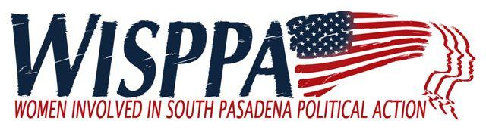

AGENDA
April 1, 2017

8:30 a.m. Coffee and Social Time
9:00 - 9:40 a.m. Business Meeting/Community Update
9:40 – 10:40 a.m. Speaker: Kelly Koldus
10:40 a.m. Social Time

MEETING LOCATION: Calvary Presbyterian Church

- Call to Order (9:00)
- Introduction of New or Prospective Members and Guests (9:00)
- New Business (9:05)
  - Confirmation of new President, Bianca Richards
  - Future Speaker ideas
  - Eclectic music festival
  - Volunteers to write So Pas Review articles related to WISPPA
- Reports (9:15) – Suggest 5 minutes each plus questions/comments
  - City Council Liaison Report (Ron Rosen)
  - Public Safety Commission (Ellen Daigle)
  - Budget Report – approval of budget (Ellen Wood)
  - Miscellaneous other reports
- Old Business (9:35)
  - Approve Minutes of February 4th meeting (Kim Hughes and Bianca Richards)
  - Other Business as time allows

- Speaker Topic: General Plan and Mission Street /Fair Oaks Specific Plan (9:40)
Hear about the why, what, and where we are at the moment.​
Kelly Koldus, WISPPA member and liaison to the General Planning Process on behalf of the Planning Commission will give an overview and lead a discussion.
Many current WISPPA members were on the original General Plan 20 years ago. They will be on hand to offer insights. City staff will also be available for questions and answers

VIII. Membership Comments and/or Announcements and Adjournment (10:40)

Next Meeting: Saturday May 6th Calvary Presbyterian Church, 8:30 a.m. coffee; 8:45 a.m. business meeting/community update; 9:30 a.m. forum speakers begin

