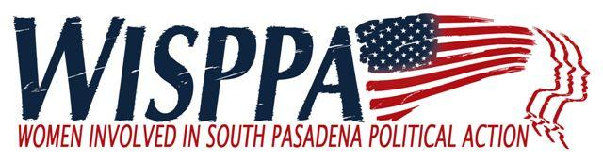

Policy Statement:
WISPPA Support of Other Organizations’ Fundraisers and Events

WISPPA receives many requests from other organizations to advertise their events to our members or sponsor or participate in their events. To remain consistent with respect to all such requests, we have adopted the following policy statement.

Sponsorship of Events: WISPPA only “sponsors” its own events or events for which it acts as co-host, unless otherwise approved by the membership of WISPPA.

Purchasing Tickets/Tables: WISPPA, itself, does not purchase tickets to or tables at events hosted by other organizations. A WISPPA member may desire to purchase tickets or encourage other members to purchase tickets to a non-WISPPA event; however, this is a member-driven activity, and not ‘sponsored’ by WISPPA.
Sharing Information: WISPPA will share information regarding events to members through emails, website posting and/or announcements at meetings for the following: (WISPPA reserves the right to determine how the information is to be communicated)

- Fundraising Events
  - Sponsored by South Pasadena non-profit organizations
  - Sponsored by non-profit groups outside of South Pasadena promoting WISPPA’s goals
  - Non-political humanitarian events held by South Pasadena residents
- Arts & Education
  - Programs or exhibits taking place in South Pasadena (i.e. Fremont Centre Theatre, art exhibits, SPARC, South Pasadena Library, etc.)
  - Programs or exhibits presented by South Pasadena residents outside of South Pasadena
  - Programs sponsored by organizations outside of Pasadena related to WISPPA’s mission statement as NWPC, League of Women Voters, etc.)
- Community Events
  - Sponsored by the City of South Pasadena
  - Sponsored by South Pasadena organizations
  - South Pasadena government meetings and events
  - Chamber of Commerce sponsored events

- Political Events – WISPPA does not endorse, support or oppose any specific candidate. Sharing information about political events with members does not imply endorsement or specific support by WISPPA.﻿
  - Events for candidates that are open to the public to attend without requiring a monetary contribution. This would include events that anyone who may be interested in meeting a candidate and having the opportunity to ask questions could attend without having to support the candidate. (i.e. Meet and greet, NWPC, etc.)
  - Candidate Forums
  - Events related to or sponsored by politicians representing South Pasadena: State Senator, Assemblyperson, County Supervisor, etc.

