WISPPA Meeting Minutes of 1.12.19
South Pasadena Senior Center Great Room, 1102 Oxley Street, South Pasadena, CA 91030

Present: Ed Donnelly, Gary Pia, Dollie Chapman, Betty Emirhanian, Ellen Wood, Bianca Richards, Barbara Sinclair,
Suzie Abajian, Sean Abajian, Kim Hughes, Herb Shon, Sally Kilby, Lela Bissner, Kelly Koldus, Judith Harris, Shadi
Towfighi, Charles Trevino, Carmen Trevino, Lissa Reynolds, Janet Braun, Mary Ferrero, Mary Urquhart, Ellen Daigle, Joe Daigle, Diane LaSell, Roxy Ortiz, Kay Findley, Diana Mahmud, Becky Thompson, Cynthia Erland, Yvonne Pine, Gretchen Robinette, Lynda Sullivan, DeLaine Shane, Clarice Knapp, Harry Knapp, Marina Khubersian, Sgt. Shannon Robledo, SPPD, Avic Manukian, SPPD, Jamie Hannibal, SPPD, Stephanie DeWolfe.

1) Call to Order: 9:35AM by newly elected WISPPA President, Betty Emirhanian

2) Introduction of Guests and New Members by President Betty Emihanian: Gina Atkinson of South Pasadena Beautiful, Marianne Bleitch of South Pasadena Beautiful, Diane Lasell, member attending her first meeting, DeLaine Shane, new member.

3) Approval of 11.3.18 minutes: Minutes approved.

4) Presentation re: “Kits for Homeless,” project of the SPPD “Police Officers Association (POA)” participated in by WISPPA: Ellen Daigle and Ellen Wood, WISPPA Board Members, presented along with SPPD Sgt. Shannon Robledo. WISPPA donated funds to allow for a shopping mission undertaken by Ellen Daigle and Ellen Wood to purchase items to make hygiene/supply “kits for the homeless.” Purchases made by WISPPA included toiletries, blankets, other necessities and back packs to hold items including leaflets prepared by the SPPD with information/contacts re: local services for homeless individuals.

5) Speaker Presentation: “Q and A with South Pasadena City Manager, Stephanie DeWolfe:” This program entailed a conversation with new City Manager DeWolfe who has spent approximately one year in the position and WISPPA Vice-President, Ellen Wood. The conversation touched upon some of the city’s most pressing issues and looked ahead to the city’s initiatives, opportunities & challenges. Discussion with audience members took place following the conversation between the moderator and City Manager. Attached to these minutes is an article which appeared in the South Pasadena Review following the meeting discussing more in depth the contents of the “Q and A” with City Manager DeWolfe.

6) Old Business: None

7) New Business:
A. Name Change of WISPPA from “Women in South Pasadena for Political Action” to “Women in South Pasadena for Public Action:” Rationale for WISPPA name change written about by Betty Emirhanian. Due to time constraints vote on WISPPA name change was tabled. A business meeting was added to WISPPA’s meeting calendar for Saturday 3.3.19 at 9:30AM to address this and other business matters.
B. WISPPA Board Report: Tabled due to time constraints.

8) Announcements:
A. Ellen Daigle announced that there will be Leo Politi Painting Exhibit starting 2.1.19 at the Italian American Museum, 644 Main Street, Los Angeles, CA 90012, iamla.org. The exhibit is free of charge. Leo Politi is an Italian American artist who created a mural for South Pasadena Library Children’s Room and donated other works of art to South Pasadena.
B. South Pasadena Beautiful—South Pasadena Beautiful is involved in beautification projects. There are currently about $30,000 in funds for this organization to work on a landscaping project at the South Pasadena
post office.

Page 2
.
WISPPA Meeting Minutes of 1.12.19
Announcements Continued:

- Diana Mahmud, City Councilwoman, discussed the city’s new “Clean Power Alliance” offerings for citizens’ electric service. A presentation will be held to further explain/clarify citizens’ “Clean Power Alliance” choices on Wednesday 2.13.19 at the So Pasadena Library Community Room, 1115 El Centro Street, So Pasadena, starting at 7PM.

- Lissa Reynolds of SPARC announced that the City of South Pasadena has partnered with SPARC to open a second SPARC gallery on the second floor of City Hall. Local resident’s, Cyndi Bemel’s, photography is currently on exhibit there through 3.3.19. The first-established SPARC gallery is located at the South Pasadena Chamber of Commerce offices on Mission Street in South Pasadena.

- The newly elected 2019 WISPPA Board was introduced and asked to stand by President Betty Emirhanian:
Ellen Wood, Vice President, Lela Bissner, Treasurer, Judith Harris, Secretary, Dollie Chapman, Membership Chair, Bianca Richards, Past President, Ellen Daigle, Founding Member.

9) Adjournment: 11:10AM by President, Betty Emirhanian.

10) Next Meeting: Saturday February 2, 2019 starting at 9AM for refreshments, Call to Order at 9:30AM at the South Pasadena Senior Center Great Room, 1102 Oxley Street, South Pasadena, CA 91030. Topic: “Community Connections---Our Natural Surroundings.”

Minutes Respectfully Submitted by WISPPA Secretary, Judith M. Harris

City Manager Discusses State of the City in WISPPA Visit
Addresses Concerns over Customer Service, Use of City Commissions and Economic Development
BY HARRY YADAV JANUARY 18, 2019
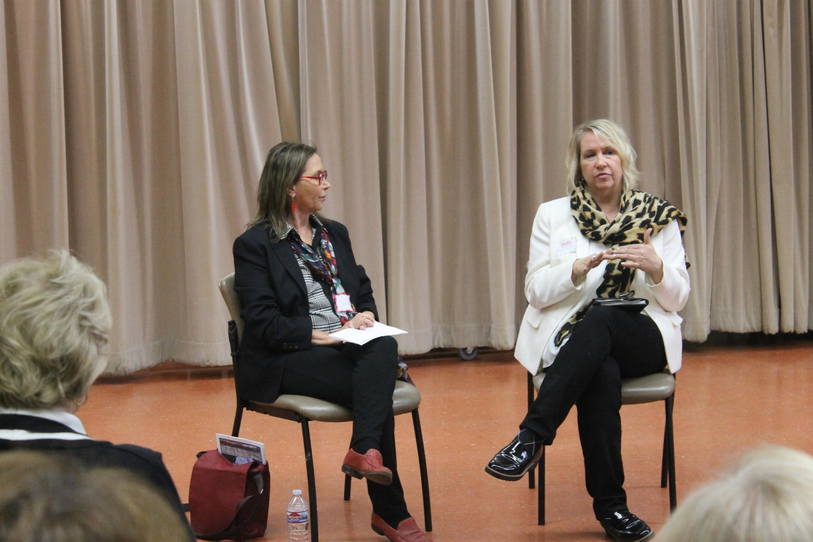

City Manager Stephanie DeWolfe paid a visit to the Senior Center January 12 to speak with Women Involved in South Pasadena Political Action (WISPPA) and other members of the public about recent changes at City Hall, upcoming challenges regarding the City budget and fiscal policy, the city’s attitude toward its volunteer city commissions and a host of other issues. DeWolfe answered questions for over an hour, first from a moderator, WISPPA Vice President Ellen Wood, and then in a town hall format from members of the audience, which numbered roughly 40 people.
A little more than one year into DeWolfe’s tenure as City Manager, the event functioned as an informal state of the city interview, touching on the most pressing issues and looking ahead to the city’s biggest initiatives.
Prior to DeWolfe’s visit, WISPPA had publicly raised concerns over the availability and responsiveness of the city manager’s office. Speaking on behalf of WISPPA at a recent City Council meeting, WISPPA’s then-president, Bianca Richards, said, “Residents and [city] commissioners commented that they have attempted to speak on the phone or meet with our City Manager and received no possible options to speak directly or to meet. Most received no response at all, and others were asked to leave a message.”
DeWolfe addressed the issue right off the bat Saturday morning.
“I’m proud to talk about our new customer care system,” she began, “because I have heard the complaints that we did have a problem with people calling city council to report issues and not getting a response, which is 100 percent unacceptable. When you call your city hall, you should absolutely get an acknowledgement in 24 hours and an answer in 48 hours. So, the fact that we were dropping some of these things was not right. We had to go in and reengineer the process and look at what was happening.
“What happens now is things come into the clerk, they log every phone call and every request,” DeWolfe said. “They respond to you immediately with a thank you and acknowledgement that the request was received. We also have a staff person dedicated now, in the city clerk’s office, to follow up on every customer care request and make sure the departments respond within the 48-hour period. We print out a status report every week and provide it to our councilmembers, so they know what questions are coming in, how we’re answering, and they know if we don’t live up to our standards of responding because they’re getting a report every week.”

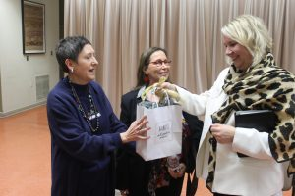
WISPPA’s Bianca Richards, left, and Ellen Woods present South Pasadena City Manager Stephanie DeWolfe with an honorary WISPPA mug.

While recent allegations of gender bias in the appointment of City commissions were not a topic at Saturday’s meeting, the City Manager did discuss at length what she feels has been the underutilization of those commissions by the City over the past year.
“I agree 100 percent that our commissions are not being used appropriately,” DeWolfe said, when asked by Wood how the city can extract the maximum amount of input from its commissions. “I don’t think we have been treating our commissions with the appropriate level of success. I don’t think they have been engaged on high level, important policy issues. I don’t think they’ve been staffed and supported sufficiently. It’s a huge priority for me… In my experience, it’s industry best practice to bring the commissions in on high level policy issues. That’s where we need the input.”
DeWolfe cited improving the quality and consistency of staff reports as one way the City can better support its commissions.
“We should be taking to our commissions a staff report that has data, analysis, alternatives and recommendations,” she said. “Then, we ask the commissions for the analysis and feedback on the report. Then, it’s up to [the commissioners] what [they] want to do with that ‘homework.’ You might tell us, as commissioners, ‘we need more data, we need more analysis,’ or, ‘your analysis is wrong,’ but we shouldn’t be expecting you to do all the homework in the first place. We haven’t even, in many cases, given our commissions the reference points, the legal precedents, they need to make their decisions. We also have a number of commissions that have received no Brown Act training. That’s inappropriate. All of those are things we’re trying to change and improve.”
DeWolfe cited her own experience as a planning commissioner in Pasadena as one reason she is able to sympathize with South Pasadena’s frustrated commissioners. “I know what it’s like to be a commissioner and come in for a meeting and there be nothing on the agenda, and you think… I want to be used, I volunteered because I want to be helpful. My goal is to fix that and elevate the roles of the commissions. I hope that is clear to you all with the Commission Congress that we will be having on February 28, which is intended to be an opportunity for our commissioners to engage with each other and the City Council in a way we have never provided before.”
Created so that all of the commissions can come together in one place to have their voices heard by City Council and staff, the Commission Congress is an event in which each commission will report out on their annual report before Council with City staff present. DeWolfe called the event both an opportunity for commissions to share information and interact with each other as well as a thank you from the City to its volunteers.
Councilwoman Diana Mahmud, who was in attendance Saturday, followed DeWolfe’s comments by reminding the audience, which was peppered with former and current commissioners, that the most effective way to communicate discontent with the city is through council liaisons.
“Each commission has a council liaison,” Mahmud said. “If you are frustrated, your first option, and, I think, most important option is to talk to this person who is there to act as an interface between the commission and the city.”
Separately, much of Saturday morning’s discussion centered around economic development as the primary means of generating income for the city. South Pasadena, like cities across California, is facing large economic liability in its near future. Due to the underperformance of the state employee pension investment fund, Calpers, the city will have to make large incremental contributions to make up for the shortfall over the next five years.
According to DeWolfe, the city has three options for balancing the budget. Those are, slashing services, raising taxes, or opening up the city to more economic development.
“Economic development, I think, is really our best option,” DeWolfe said. “We had little economic development (previously) because of the battle over the 710 (freeway extension). People were cautious about starting a business here, or buying property, or even investing in something they already had because they didn’t know what was going to happen. They didn’t know whether the freeway was going to come through and blow our city into two pieces, and really have economic impacts. Now, we have a lot of interest in South Pasadena – the freeway is dead. I want to be very careful to say this doesn’t mean we swing the doors open and bring developers in and build a lot of ugly buildings. We need to hold the line where anybody that invests here invests in a way that strengthens what we already have.”
The City Manager was quick to point out, however, that increasing economic development is much more complicated than simply resolving the issue of the 710 freeway extension.
“We need to do some things to facilitate [growth],” she said. “We now have an interim planning director (David Bergman) with expertise in economic development as well as urban planning. And, we are building a team, we are reallocating resources within the city to be able to focus better on some of these things.”
DeWolfe also said that the City would be preparing an economic development plan and strategy over the next six months that will require compiling a large amount of data. “We need to be strategic about our economic development,” DeWolfe said in response to Wood’s question about the type of businesses the City is looking to attract. “We need to gather data. What’s our mix of businesses? What kind of shoppers are we attracting or not attracting? Where are they coming from? How long are they staying? Get all this data, then analyze the data and find out what are the opportunities that the market will support. We want to be careful that there is science behind what will be successful here. We can say, for example, we are leaking hardware customers because we don’t offer that. So, we need to make sure the market will support our strategy.”
This means, said DeWolfe, that city staff “will be knocking on [residents’] doors a lot over the next six months” to compile public input on the preferred direction of the South Pasadena economy.
“Ultimately, that document (compiling all of the information) will be adopted by council as part of the budget process,” DeWolfe said.
The mention of a public input survey elicited a number of murmurs from the crowd. One of WISPPA’s founding members, South Pasadena resident Mary Urquhart, asked DeWolfe if she was aware that in recent years, residents and City staff have spent a great deal of time and resources compiling information regarding economic development and wishes for the city’s future.
“Our city went through a huge survey, and our residents spent a huge amount of time, to come up with these answers,” Urquhart said. “I mean, a tremendous amount of time. How can this information that we have already be utilized?”
DeWolfe said that yes, she was aware of the previous information compiled and that it will be used, but that the City is looking to expand upon its current data to come to a consensus.
“Some of this work was done as part of the general plan,” DeWolfe said. “But, an economic development strategy is a very different animal from a general plan. An economic development strategy builds upon a general plan. It’s really considered an implementation tool of the general plan. So, yes the work that has been done in the focus groups and the charrettes and there was some consultant work done, all of that information we have and that will serve as the basis of where can move on. I think though, there is still some additional input and some additional data that we can get from the community because there is not a draft strategy put forward for feedback from the community.”
DeWolfe also said the information gathered so far provides no consensus. “Frankly, we heard a lot of different opinions from a lot of different perspectives, there was no consensus. So, we need to come back to the community and say, here’s what we think is the right balance… is this right? Is this the best compromise, because clearly it’s going to be a compromise.”
South Pasadena resident and locally based architect, Becky Thompson, raised a more general concern to DeWolfe regarding the practicality of plans for economic development.
Said Thompson, “In my business, dealing with the planning and building department a lot, I have noticed there are a lot of changes going on, I’m concerned about the way the community responds to change. I’m worried about pushback in the community… I’ve seen them kill development projects that would have been great – not only for our economic base but also for our community’s quality of living. Is there any way you guys can help buffer between the change in the community that needs to happen, I feel, and the pushback from people who want no change?”
In response, DeWolfe said that improved support and management of the City’s commission process is the most effective tool the City has.
“The land use process, for example, involves the use of a number of commissions,” DeWolfe said. “You’ve got input from the Cultural Heritage Commission, the Planning Commission, the Design Review Commission, and others… It’s really critical from an economic development perspective that we create a path through the commissions that is open and transparent so that our community can see what’s going on, what we’re talking about, why decisions are being made, but also that we are supporting good projects that want to come through.”
To read more of what was discussed during the city manager’s visit, in which she also addressed the issues of affordable housing, public art, and more, visit www.southpasadenareview.com for a full transcript of the morning’s meeting.

